5303 ASDS PROJECT 2

Q1: Use sample function to generate a random 10x10 matrix A with integers in [-10, 10] and  
compute the determinant of A.

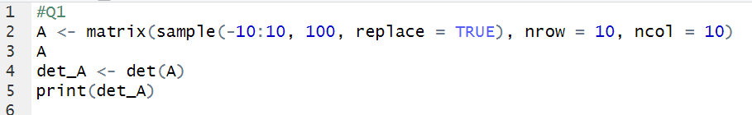

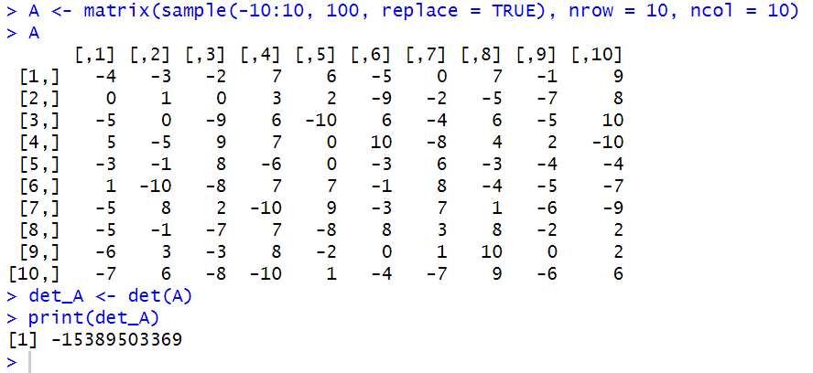

Q2: Verify whether A is invertible. Justify.

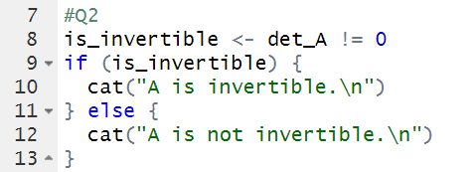

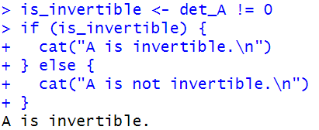

Q3:  
a). If your A is NOT invertible., then regenerate A for this question. Otherwise, continue to 3b).  
b). Verify the determinant of inverse of A equals to 1 over the determinant of A.

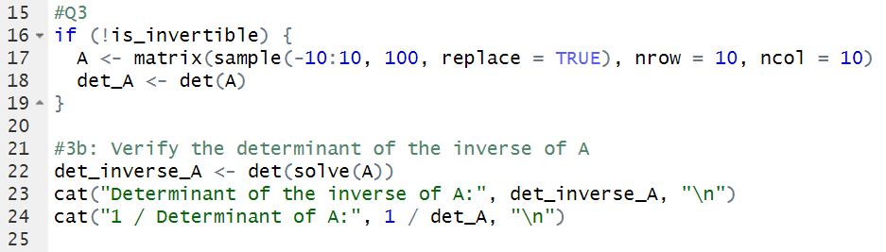

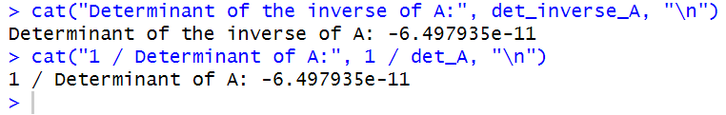

YES, the determinant of inverse of A equals to 1 over the determinant of A.

Q4:  
a). Compute the null space of A.

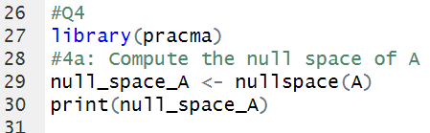



b). How many solutions do you expect Ax=b to have and why? b can be any 10-dimensional real  
vectors.

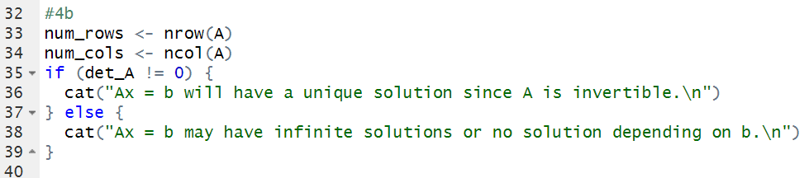

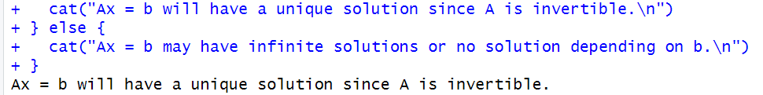

Q5:  
a). For the null space obtained in 4a) Provide the vector(s) that spans the null space. Define the  
spanning set.

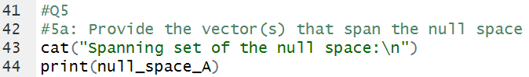

b). What is the different between a vector that span a vector space and the spanning set.



Q6:  
a). Generate a random 3 x 5 matrix A with integers in [-10, 10] and a solu4on vector b with real  
numbers in [-5, 5].

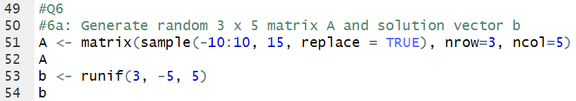

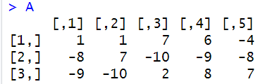



b). Obtain the vector space including all the solutions of the system of equations Ax=b.



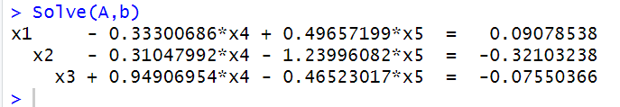

Q7:  
a). Generate a random 4 x 8 matrix, find the rank of A, and the rank of transpose of A. Compare  
these two ranks and show your result.

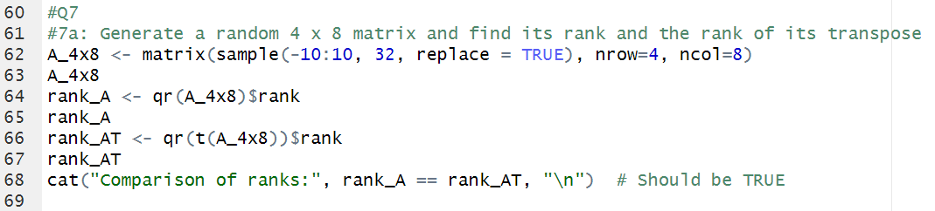

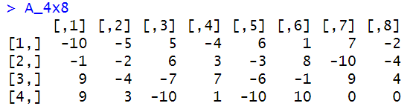

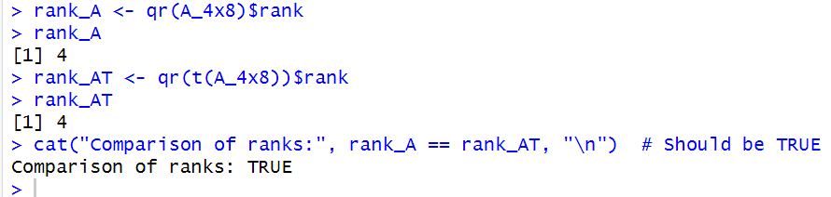

b). Find the rank of null(A), and compare the rank(A)+null(A) with the number of columns of A.

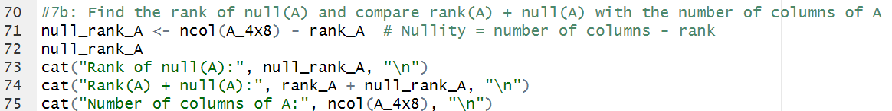

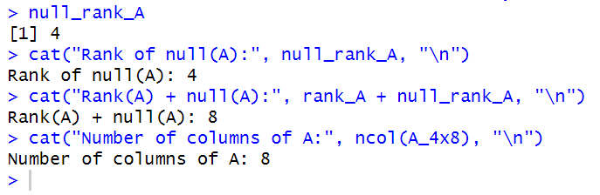

Q8:  
a). Generate two random vectors v and u with the size defined by yourself. Generate a matrix  
from these two vectors. (Hint: use v \* u^T)

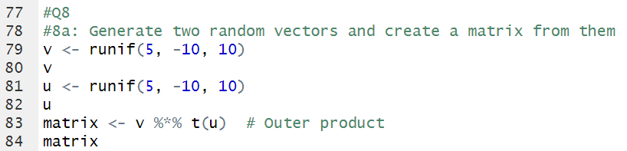

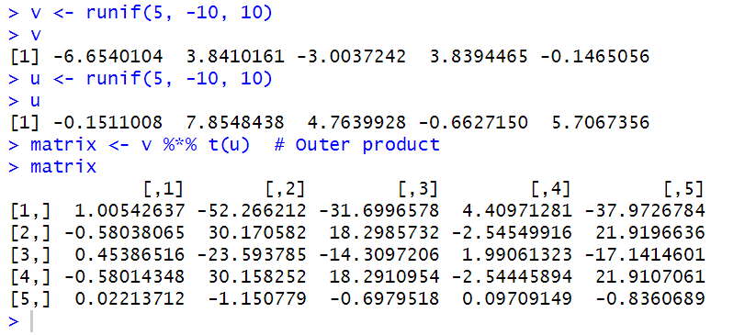

b). Find the rank of this matrix. Find the ranks of vector v and u, respec4vely. Compare these  
three ranks with each other and give your conclusion.

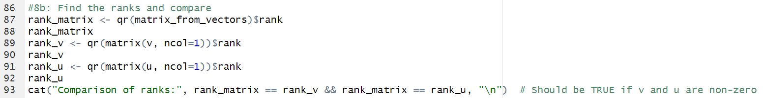

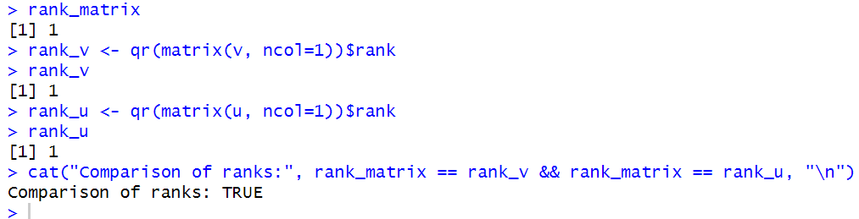

Q9:  
a). Generate a square matrix A with real numbers, of a size defined by yourself. Find an  
orthogonal basis of image of A and an orthogonal basis of null of A.

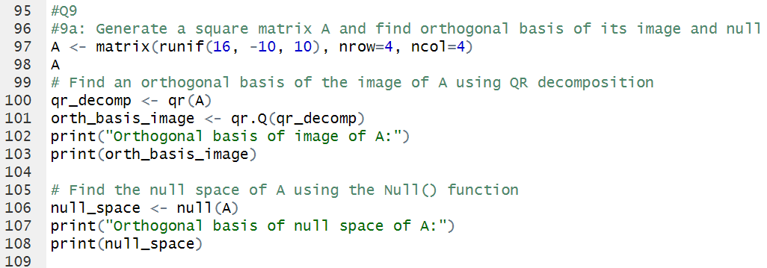

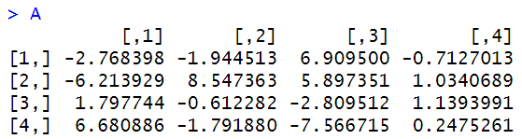

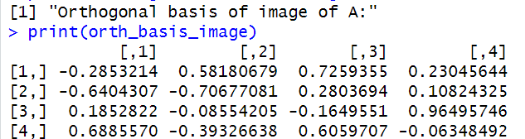

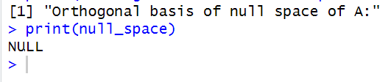

b). Find the orthonormal Bases of image of A and null of A, respectively.

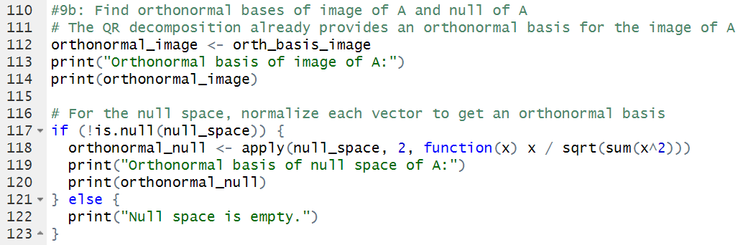

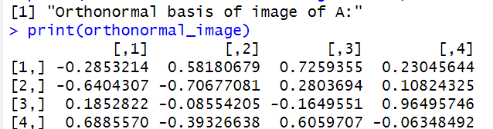

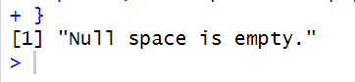

Q10:  
a). Generate a real random square matrix A with the size defined by yourself. Find all the  
eigenvalues and corresponding eigenvectors of A.

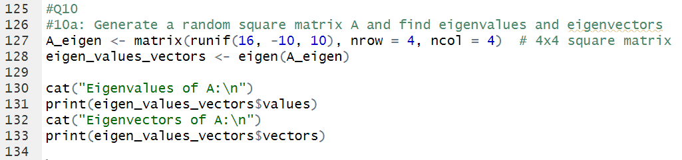

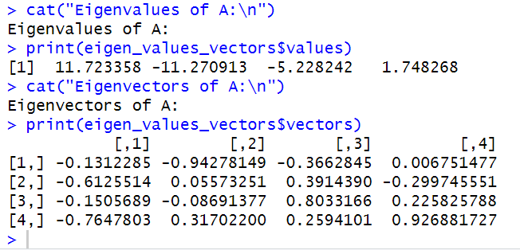

b). Check if the eigenvectors from different eigenvalues are orthogonal to each other. If so,  
please state your conclusion.

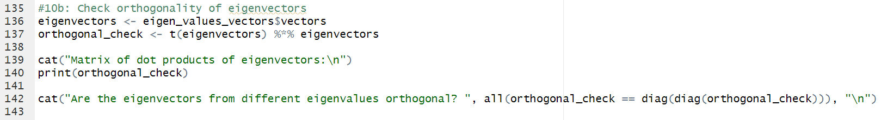

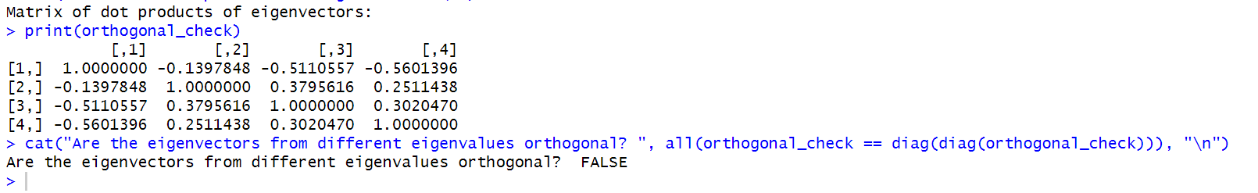

Bonus Questions:  
a). Generate a random square, and inver4ble matrix A with the size defined by yourself.

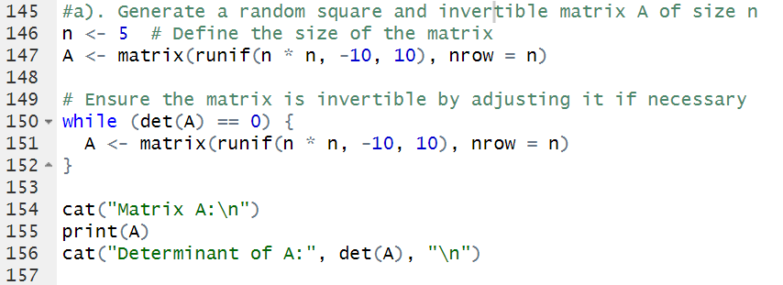

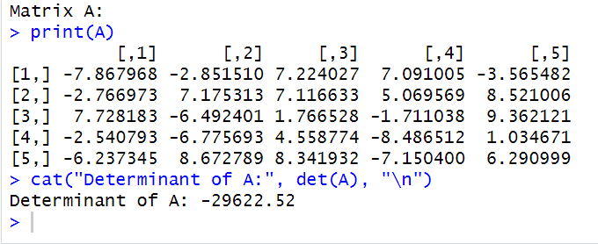

b). Design the Gram-Schmit Algorithm in R and find the orthonormal basis of image of A.

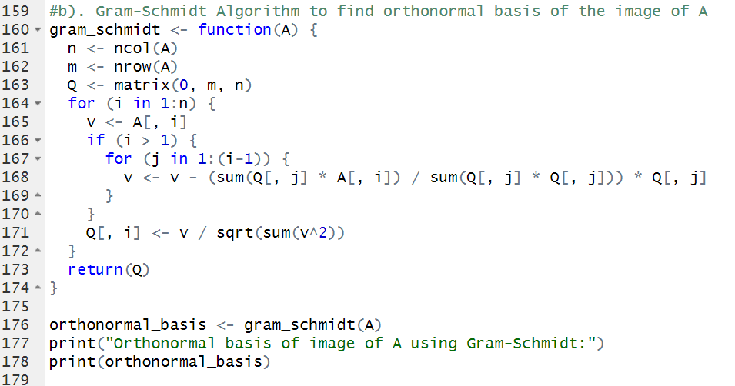

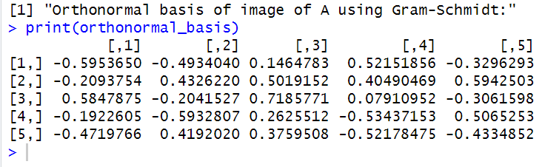

c). Generate a real random square matrix A with a size greater than 1000.

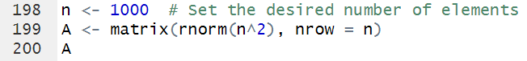

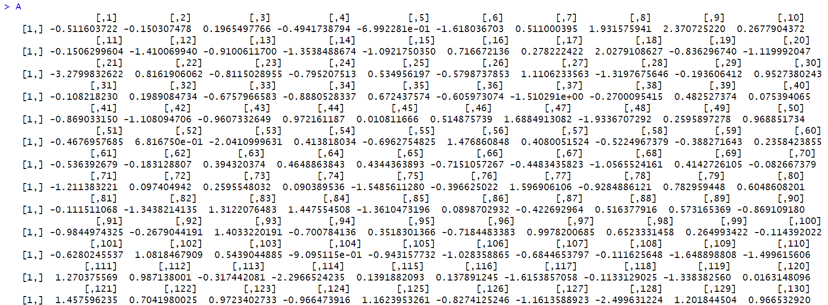

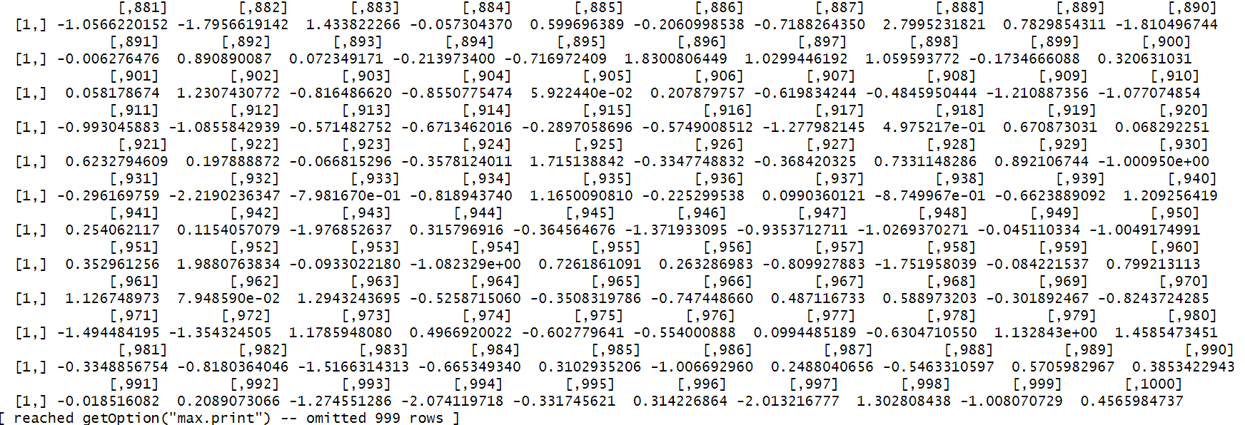

d) Try if you can get all the eigenvalues of A and all the eigenvectors of A. How many eigenvalues and eigenvectors can you get from R?

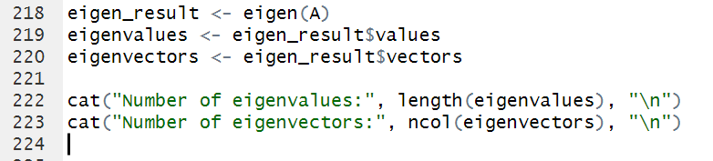

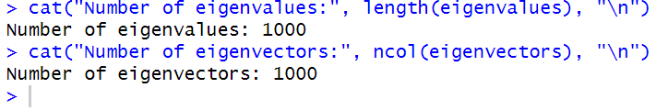

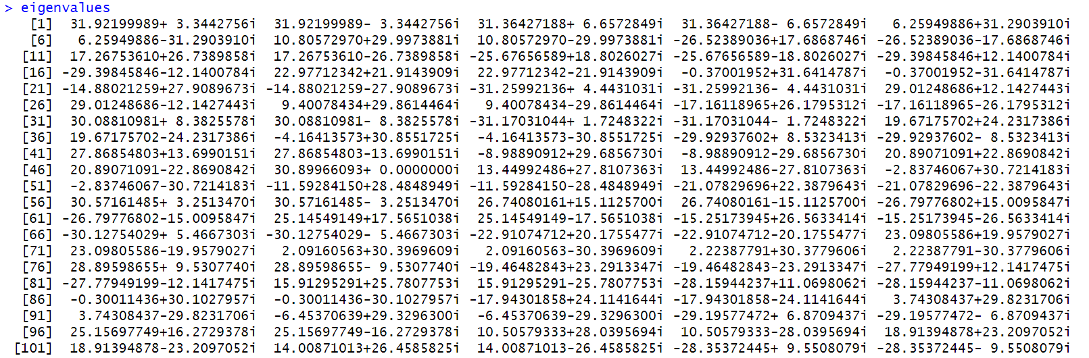

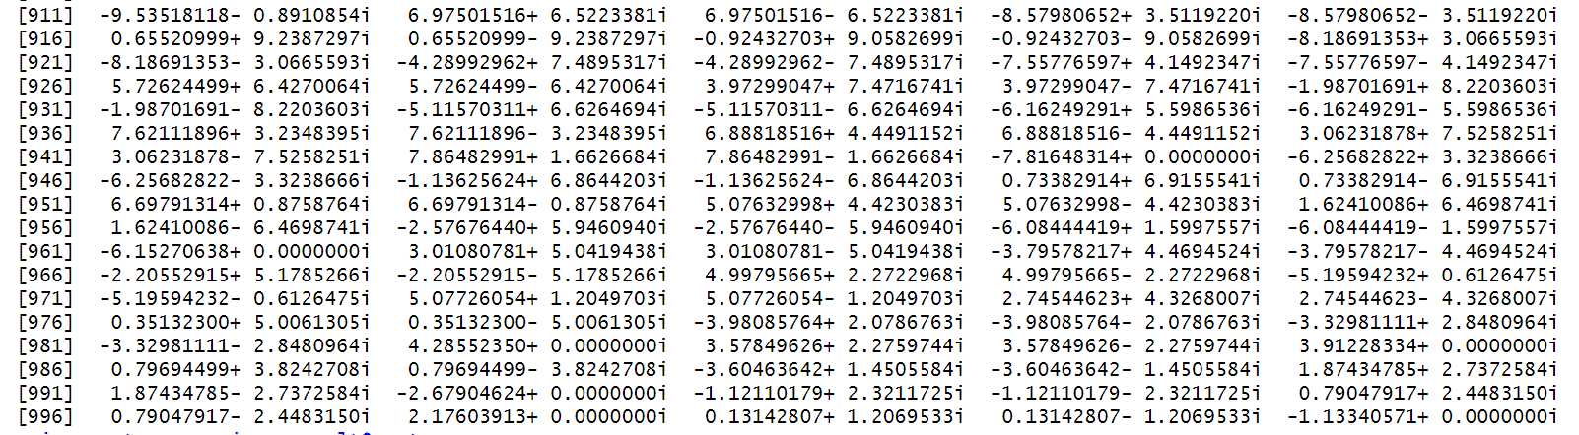

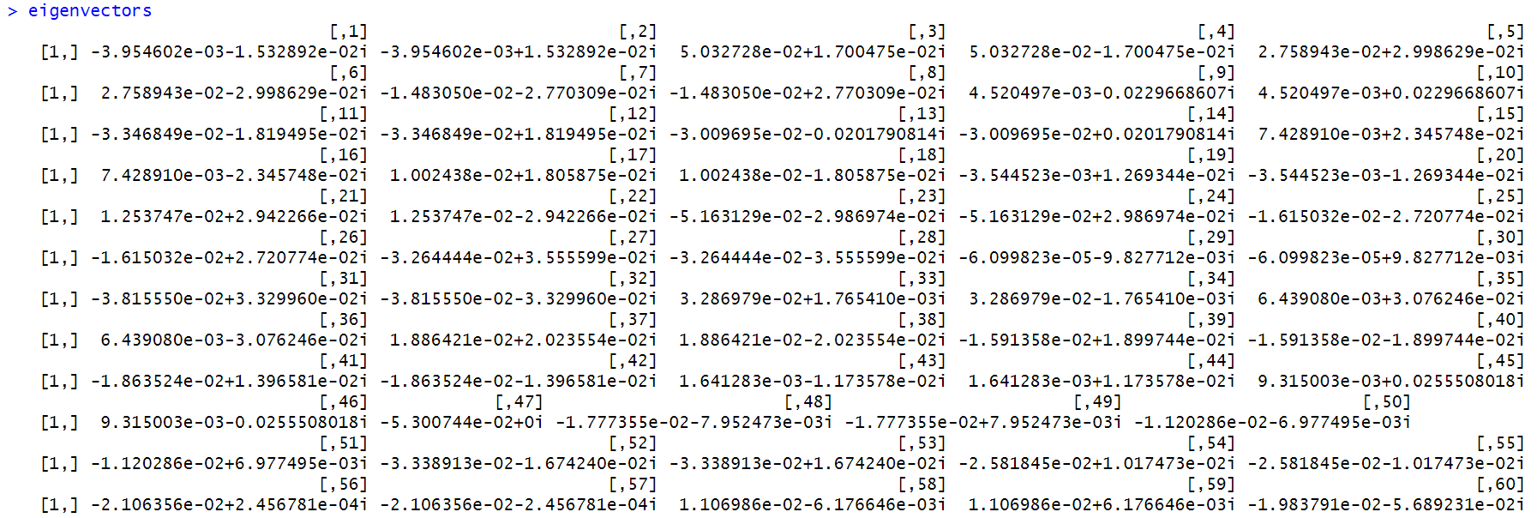

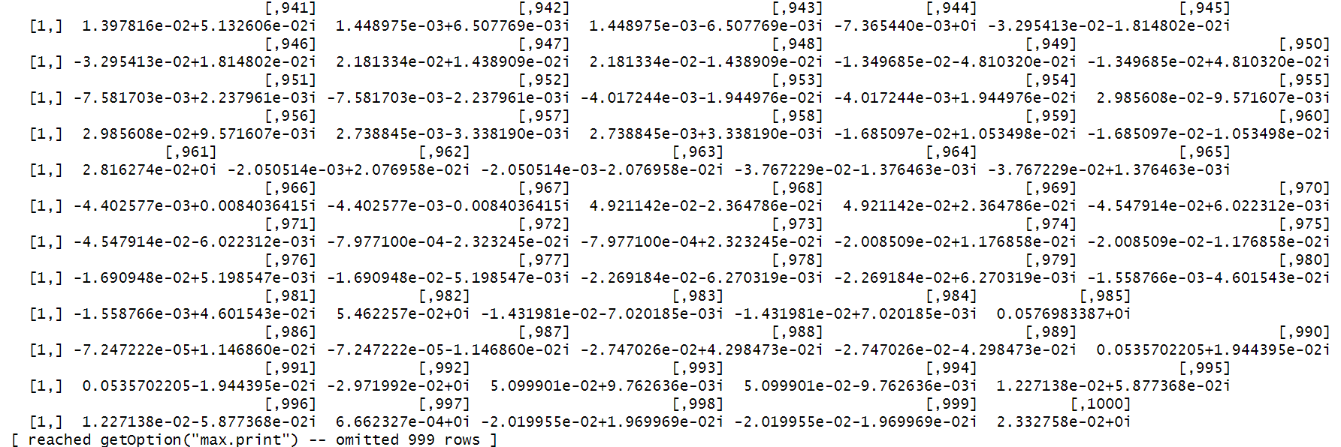

Challenge Yourself:  
a) For matrix A, defined in Bonus Question a). Find the QR decomposition of A. Write down the  
Q and R matrices, respectively.

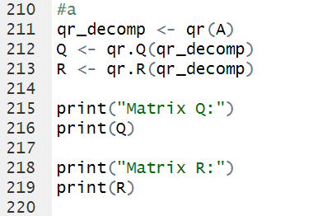

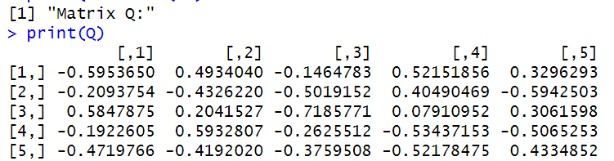

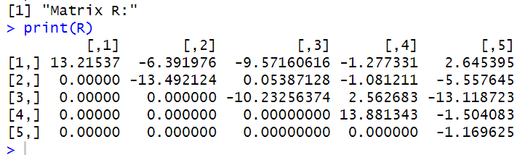

b) For matrix A, defined in Bonus Question c). can you just get the largest eigenvalue of A and  
its eigenvector.

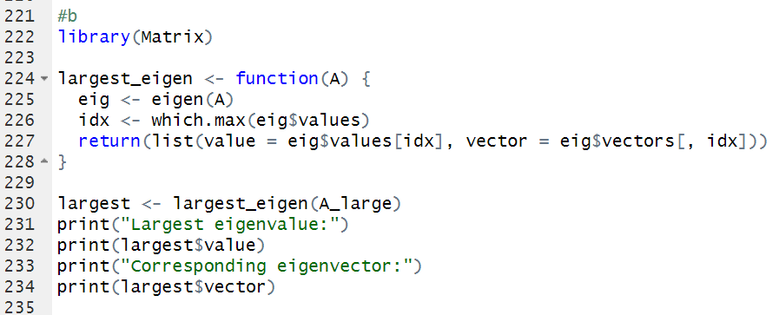

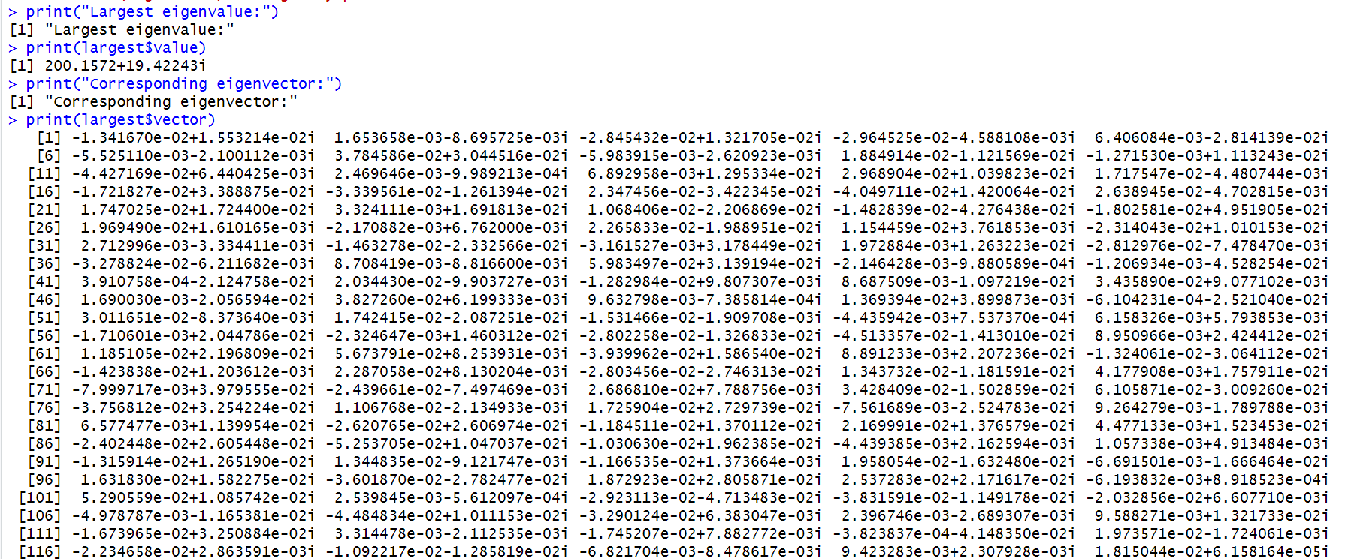

c) For matrix A, defined in Bonus Ques4on c). can you just get the smallest eigenvalue of A and  
its eigenvector

